Faculty of Engineering, Applied Sciences, and Technology
Lab Project

Course Code: BCS202 | Course Name: Introduction to Computing Science II
Date of Submission: 18th November 2025 | Instructor(s): Dr. Mehak Khurana & Dr. Hamza

DETAILS OF GROUP MEMBER
NAME OF STUDENT | STUDENT ID
Alisha Taibek | 20240005088
Ayham Nassif | 20240005740
Mohammed Azazi | 20240005212

PHASE 2: Core Functionality with Exception Handling

MENU-DRIVEN INVENTORY MANAGEMENT SYSTEM
Objective: Implement all menu operations and ensure exception-safe execution.
- A menu-driven interface in MainApp, that lists options and operations for the user to pick from.
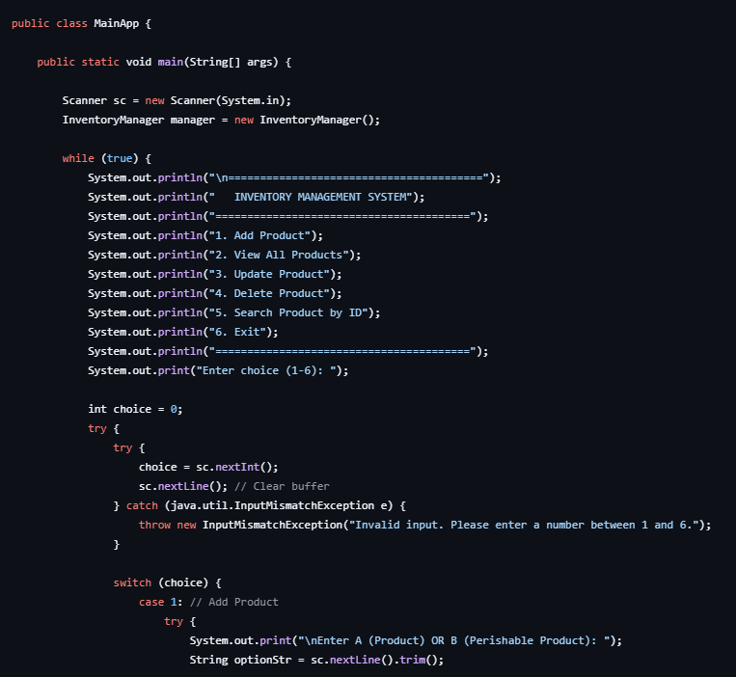
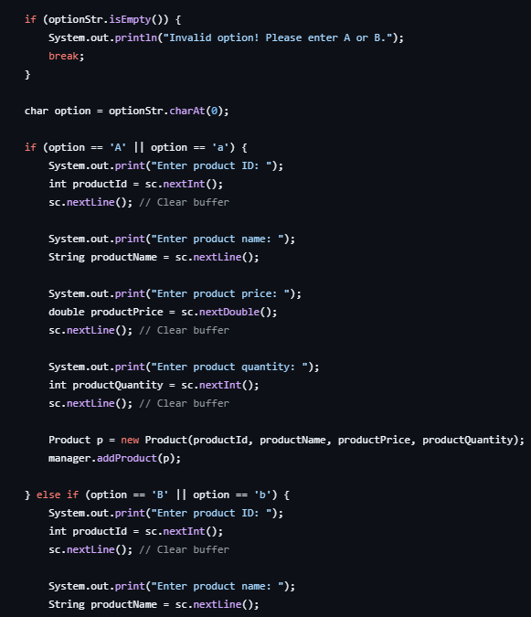
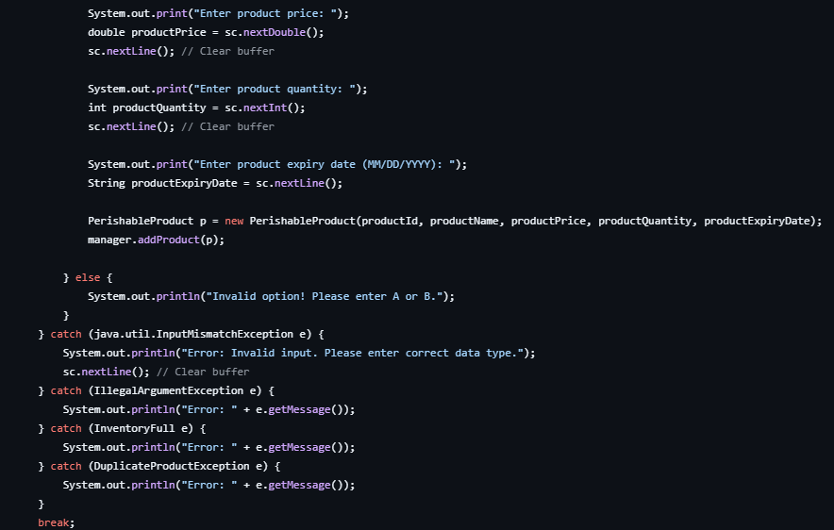

- InventoryManager.java file that contains the operations that can be done by the user to the list of products:
We have a products array that contains 50 (maximum number) cells with default values, and will store the products when created.
- An addProduct method that checks whether the product the user is trying to create is existent; if existent, it throws a custom exception DuplicateProductException that alerts the user, and if non-existent, it will add it to the list.
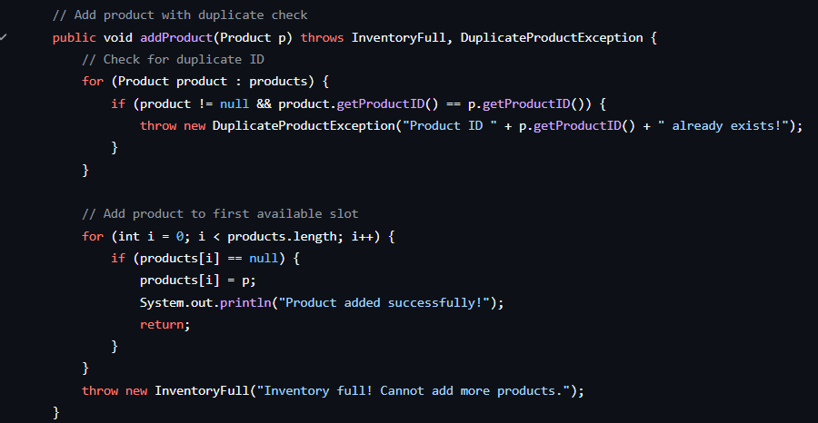
- A view method that displays all of the available products in the list using the already existent displayProductInfo method within the Product.java file.
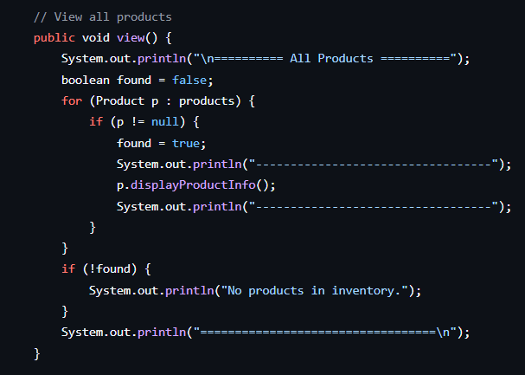

- An updateProduct method that uses setter and getters from the Product.java file to retrieve the private variables of a product. It then updates the product details using the values given by the user.
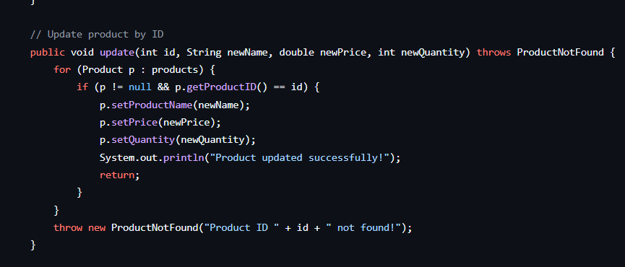
- A delete method that checks whether the product ID entered by the user is existent, and if so, deletes it, otherwise throws a ProductNotFound custom exception which alerts the user that it was not found
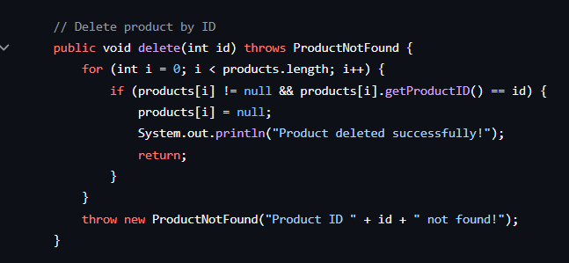
- searchProduct method that searches the product using product ID that was inputted by the user, and if the product doesn’t exist, throws the ProductNotFound custom exception.
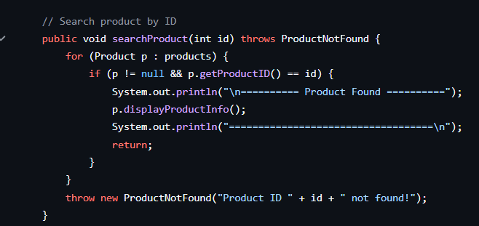

- Implementing Exception Handling
- InputMismatchException that is thrown when the user enters a value of the incorrect type. It is caught in the input-handling sections. It has a constructor that calls super(message) to pass an error message.
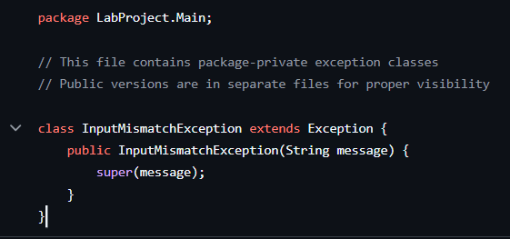
- InventoryFull, a custom exception that signals that the inventory of 50 products is full.
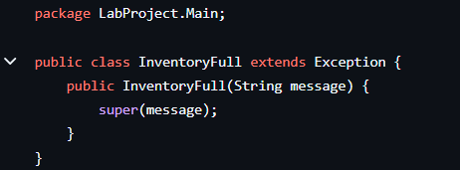
- DuplicateProductException, a custom exception that signals that the product with the given ID already exists in the array.
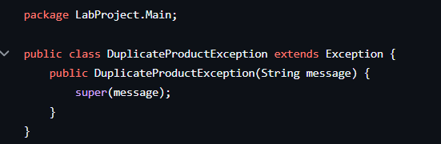
- ProductNotFound exception that signals when the given ID does not match the ID of any product that’s in the inventory.
The MainApp.java has a try-catch for invalid input types:
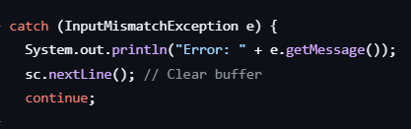
The operations throw exceptions when the errors happen, and they are caught in the main program since the method is called within the try-catch block. Example:
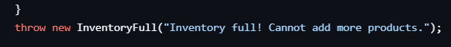

- Testing Input:
